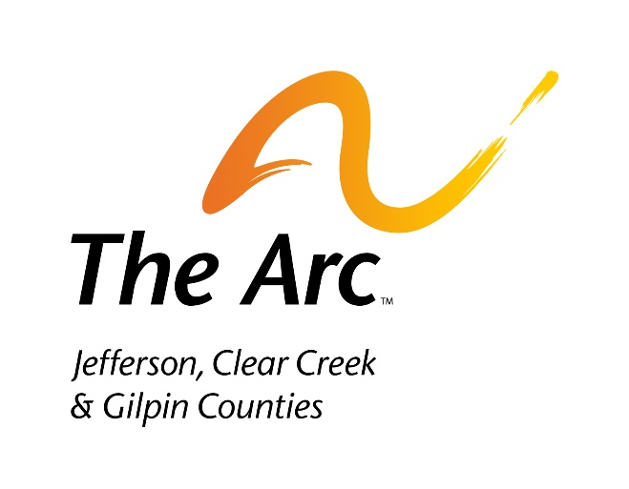
The Arc – Jefferson, Clear Creek & Gilpin Counties
Strategic Plan for FY23-25
Approved by the Board of Directors 8/17/2022

Goal 1: People with IDD and their families are at the center of everything we do. Intent: Engagement and guidance in decision making
- Understand lived experience by asking and listening to amplify the direct voices of people with IDD.
- Ensure the people we serve are well-informed about issues that directly affect their lives; empower and support them and their families to be fully engaged in their decision-making.
- Educate the people we serve about what we’re doing at The Arc and engage them and their families in governance and program development.

Goal 2: The Arc is the destination for participation for our community. Intent: Participation
- Improve accessibility, inclusion and diversity at The Arc
- Demonstrate the value of people with disabilities and the value of The Arc in our community
- Understand and reduce the barriers to participation in programs, fundraising, volunteering, events, board engagement, and employment

Goal 3: Understand and anticipate the needs of people with IDD and their families and prepare them to successfully navigate life transitions across the age spectrum. Intent: understanding for now and the future
- Engage in actionable qualitative and quantitative research to understand a full range of perspectives that includes people with IDD, family members, community partners and the greater community.
- Proactively seek out information on potential systemic changes that would directly impact people with IDD and their families, as well as broader environmental trends.
- Based on what we understand and anticipate, develop new and relevant activities, materials and resources.

