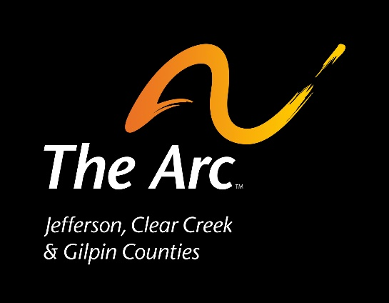

Memo
To: | Membership of The Arc-Jefferson, Clear Creek & Gilpin Counties
From: | The Arc-Jefferson, Clear Creek & Gilpin Counties
Date: | May 14, 2021
Re: | Proposed Bylaws Revisions

This document describes the major changes to the Bylaws and the intent of those changes. These changes will be voted on by the Membership at the Annual Meeting on June 30, 2021.

Article III – Membership

This section and the changes to the wording reflect the desire to have members who (i) annually donate to receive their membership privileges; and (ii) provide membership privileges to those individuals we support during and after the advocacy process. Those individuals who become members through participation in the advocacy process need not make any financial contribution to become members, and their membership will be renewed annually for as long as they wish. This section was also updated to eliminate a prior membership category which is outdated and no longer serves a legitimate purpose- the “family membership” category.

Plain Language: Everyone who gets help from The Arc can choose to be a member and they will not have to pay dues. People can also be members if they donate any amount of money.
ARTICLE III—Membership
- Section 1—Membership
Membership in the organization shall be open to all interested persons. Persons may express interest by either making an annual financial contribution no later than 30 days prior to The Arc’s Annual Meeting, or by expressing interest in Membership at any time during or after the advocacy process. Membership obtained through the advocacy process has no expiration date. Membership in The Arc is individual in nature.
- Section 2—Privileges and Responsibilities
. Members shall be entitled to all the rights and privileges of this organization and shall share in its responsibilities, including voting rights in the General Membership meeting. Each Member of The Arc is entitled to one vote. Membership in this organization includes additional membership in The Arc of Colorado and The Arc national organization).

Plain Language: Each member can vote at the Annual Meeting. Members also belong to The Arc of Colorado and The Arc US.
- Section 3—Resignation and Termination
A member may resign at any time with written notice to The Arc. Membership may be terminated by the Board of Directors for violations of The Arc’s Code of Ethics.
Plain Language: Members can choose not to be members at any time. The Arc can take away membership if someone doesn’t follow The Arc’s Code of Ethics.

Article VII – Board of Directors

Section 6 – Powers

Language was added to reflect the importance of strategy, governance and the mission.

Plain Language: The Board is responsible for the future of The Arc and can only spend money to help people with IDD. It can only spend money if it has it.
Section 6—Powers
The Board shall be responsible for the strategic direction, governance, business and policy decisions of the organization. The Board is authorized to expend funds of the organization in support of its mission and purpose, but may not exceed the net worth of the organization.

Article X – Committees

Added the Resource Development Committee in the opening paragraph, as well as adding it as Section 4; this change reflects the ongoing importance of this Committee.

Plain Language: This part adds a new committee to the list that helps raise money for The Arc.
ARTICLE X—Committees
The standing committees of the Organization shall be the Executive Committee, the Finance Committee, Resource Development Committee, and the Governance Committee. The Board may establish other committees and task forces as required. Unless otherwise stated in the Bylaws, appointment to committees is made by the President. Committees are charged with making recommendations to the Board as a whole and may not act outside of full board authority, unless otherwise directed in the Bylaws.
- Section 1—Executive Committee
The Executive Committee shall be comprised of the Officers of the Organization and if elected, the Immediate Past President. The Executive Committee shall be responsible for assisting the Board of Directors in fulfilling its responsibilities in accordance with its Board-approved Charter.
- Section 2—Finance Committee
The Finance Committee shall be responsible for assisting the Board of Directors of the organization in fulfilling its fiscal and oversight responsibilities in accordance with its Board-approved Charter.
- Section 3—Governance Committee
The Governance Committee will assist the Board of Directors of the organization in fulfilling its oversight and fiduciary responsibilities in accordance with its Board-approved Charter.

- Section 4 – Resource Development Committee
The Resource Development Committee will guide the Board in development of fundraising strategies to help ensure the financial viability and stability of The Arc.

